# Security

*”Keeping the Discord safe & users safe from crypto scams”*

Discord itself provides out-of-the-box auto-moderation features for the servers, but still, we will/can add

* **Wick** **Bot**

Averification system to ensure human-only participation,

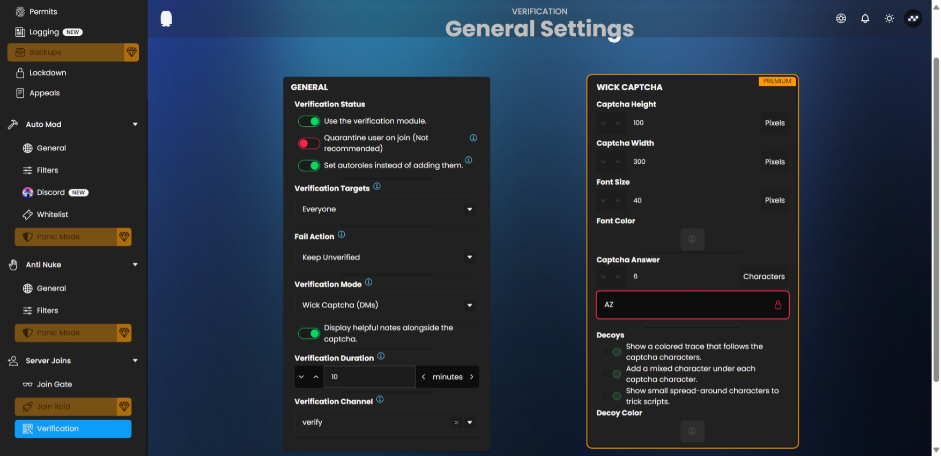

* Wick bot can also be setup as a **link scanner bot.** 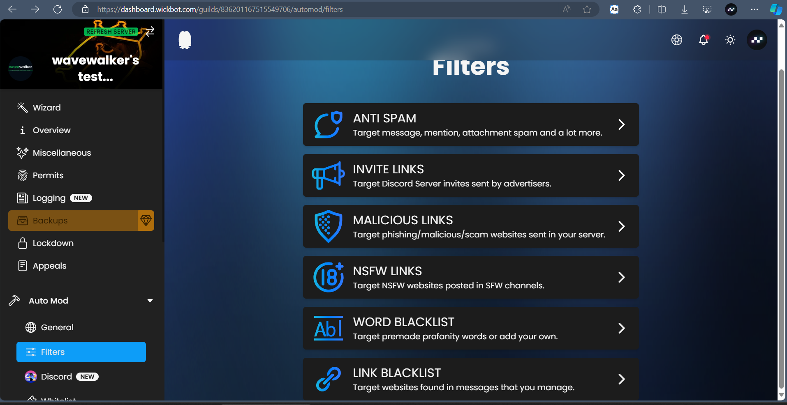
* Detect and ban spam messages using custom alias words. Wick bot can do it.
* Also please make sure to have a backup of your server with **Xenon bot.** I’ve always created backup for every server I made for clients.

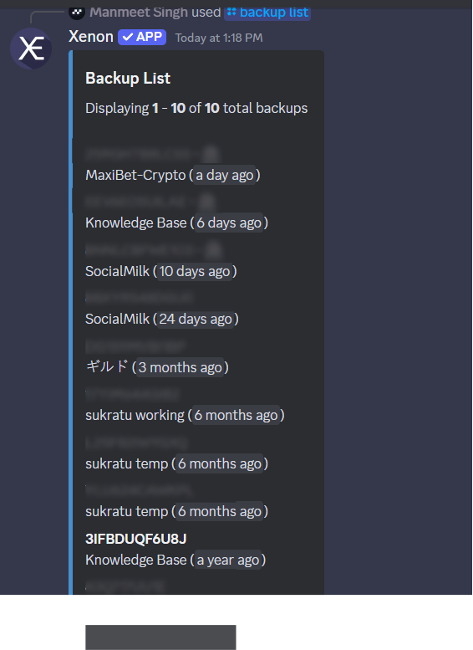

# Authentic discord community

*“Adding in custom discord ideas that link to our mission of creating an epic community driven timeline on Cardano's blockchain infrastructure. Moments (posts) = blocks of time.”*

Need clarity on this flow

Members post on discord channel and that should reflect on website? ⤵️

➡️ Discord API could help in fetching the posting time and that post from that channel and add it to the site AdaMoments[,](http://adamoments.io/) with your dev

# Community growth

*“Adding Discord features that will incentivize our users to grow the community and be active”*

Here are some of my suggestions, to increase an informal engagement:

1. We can setup reaction roles
2. Displaying server statistics to keep members informed and engaged., many fun games can be added (count to infinity, word guessing, RPG, etc.)
3. Music bots
4. Hosting giveaways with respective feature-rich bot

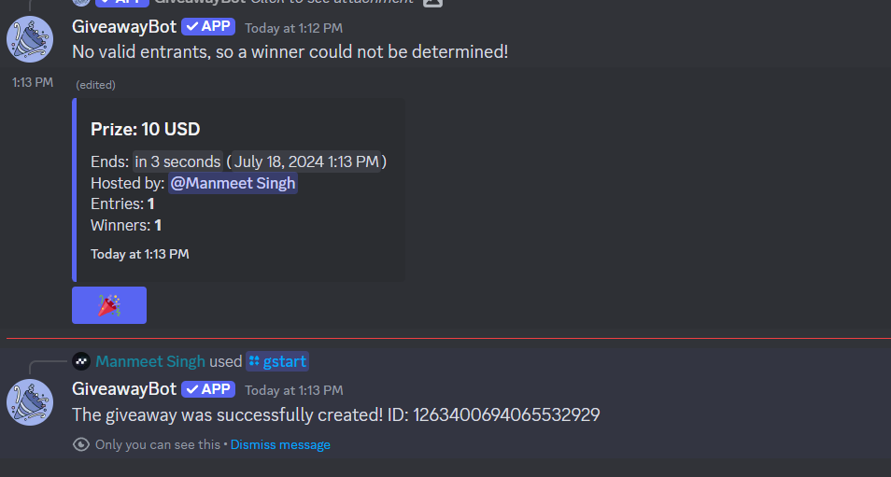 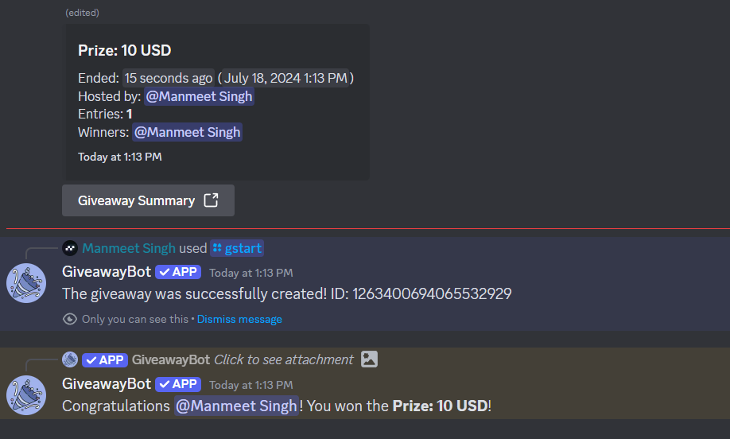

For efficiency-focused interactive features:

1. A “Forum” **was done as suggestion channel** channel where users can raise queries, engage in discussions.
2. Ticket raising system a managed way to resolve members queries

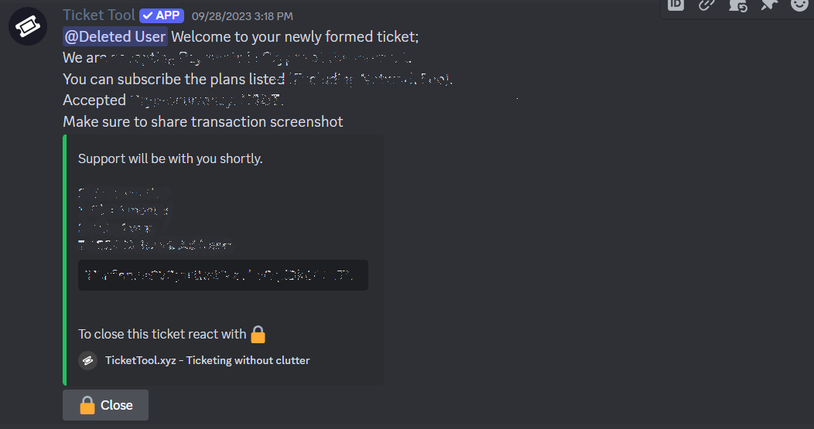

1. Creating polls

Also I believe you possess the most insights into what will benefit your community actually, I would insist to discuss it with your team and please let me know.